Zhong zhen (vela)

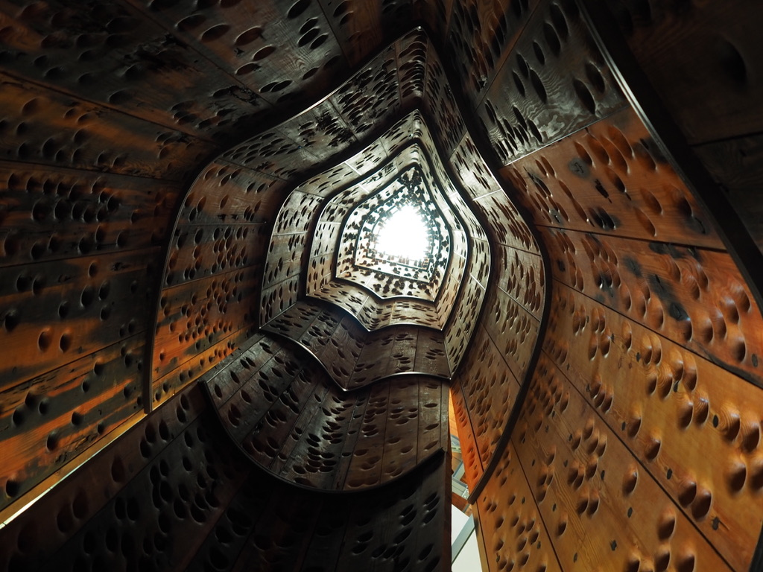After the trip in MOHAI, a museum exhibits the history of the development in Seattle, I know several things about the innovation example that happened in Seattle.

In the first floor, I can see the car that be used to carry the log, very interesting things is that the cut the car’s engine into slice and let people see the inter-structure of that car,

The most awesome things in 1st floor is the body of an old wooden ship,

extremely tall with a lot of holes on it. They also hang on a us mail airplane and a big R character under the cell,

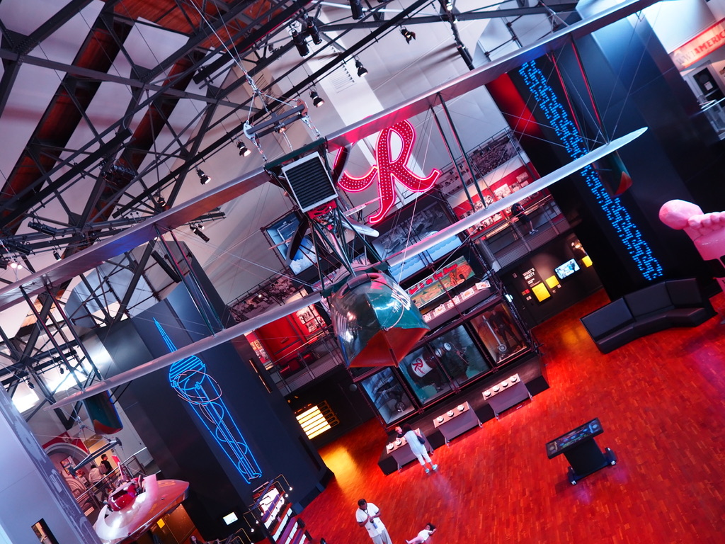and I took some nice photos with these things, although I had to look after their history on the website after.

And there is another area let people see the innovation things in Seattle is an innovation wall. I’ve seen a lot of things that is normal in our real life, I’ve never thought that these things are been created in Seattle, like sonic toothbrush, and the aluminum bicycle framework. The most interesting this is a rain-ball instead of the snow ball that fit the weather in Seattle more properly.

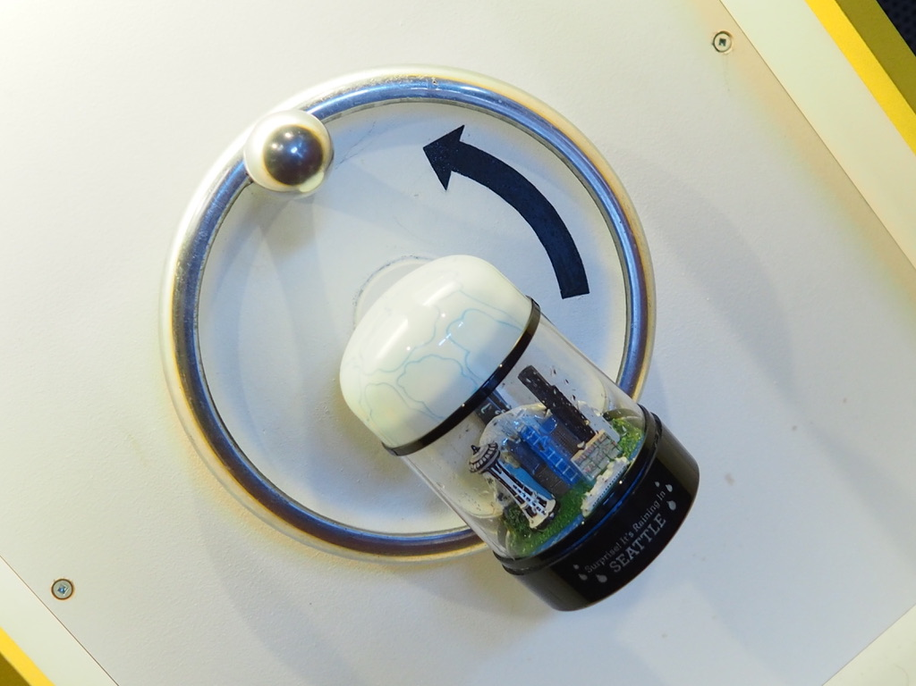

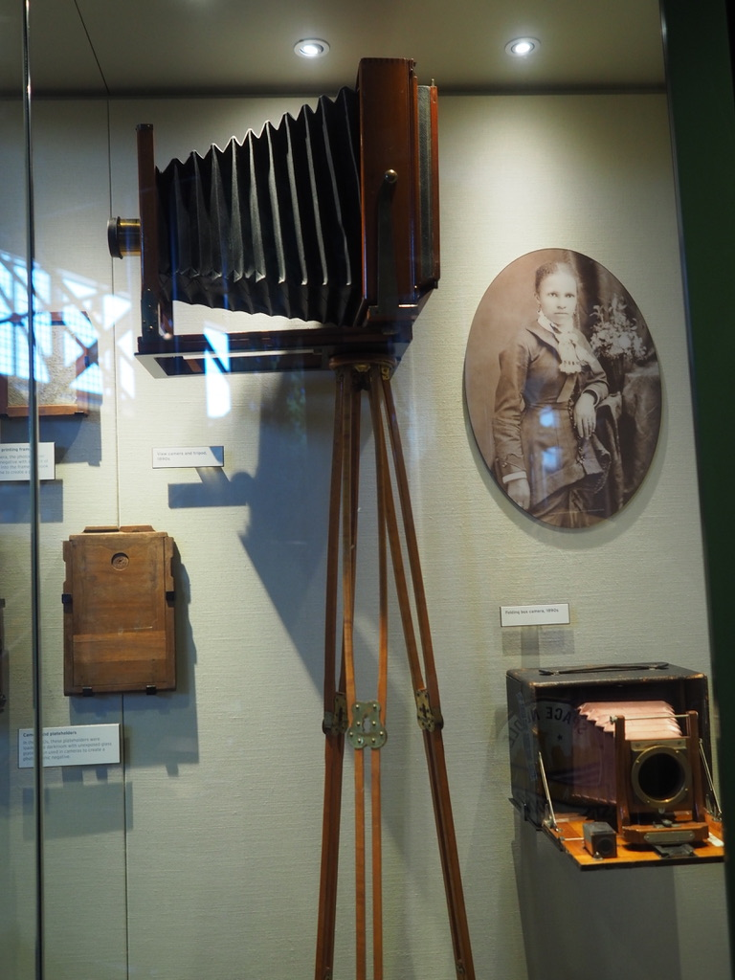On the 2nd floor, it took me a lot of time to find the answer of that form, and disturb me to see the things I like because I am afraid about time. but I still find something that is attractive, the first thing is the tribe’s story explain why frogs lives in marsh. They also exhibits things that be used to make the tribes lives better in the natural environment. When time comes to the Golden-fever, it seems that Seattle become to have factory or industry for the first time, Miners bring machines, inspiration and their life to struggle for living in Seattle, and the Rail is building at the same time, transport the coal and log the other US area.

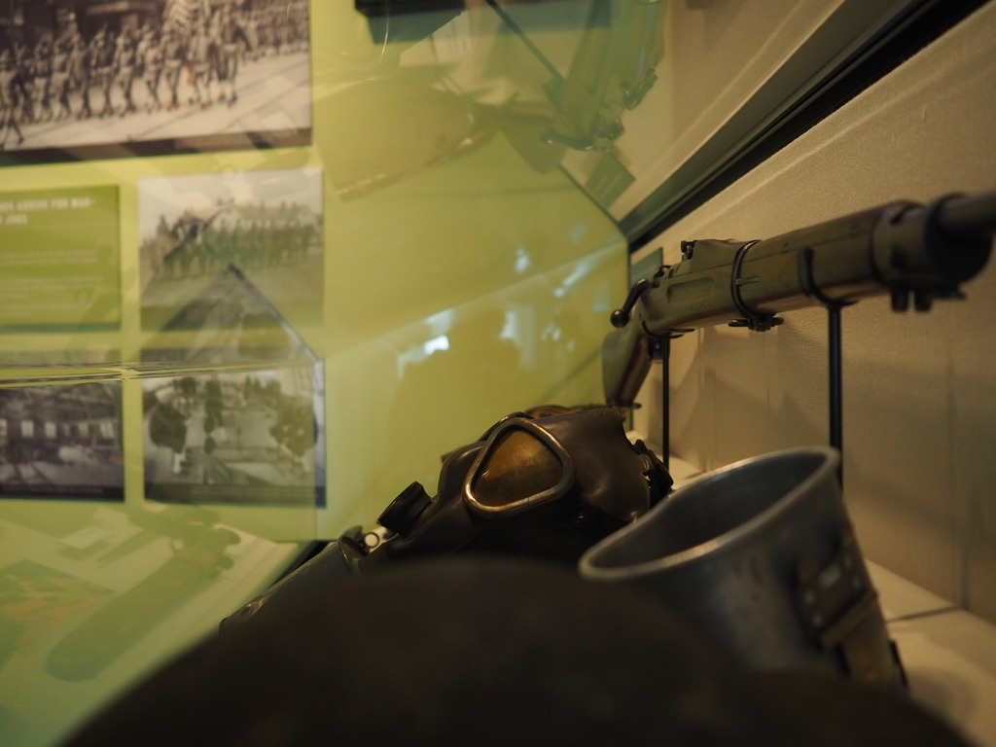And two world war gives plays to Seattle Industry potential, ship manufacturing, airplane manufacturing and ……. Wine factory. Extremely brutal but realistic.

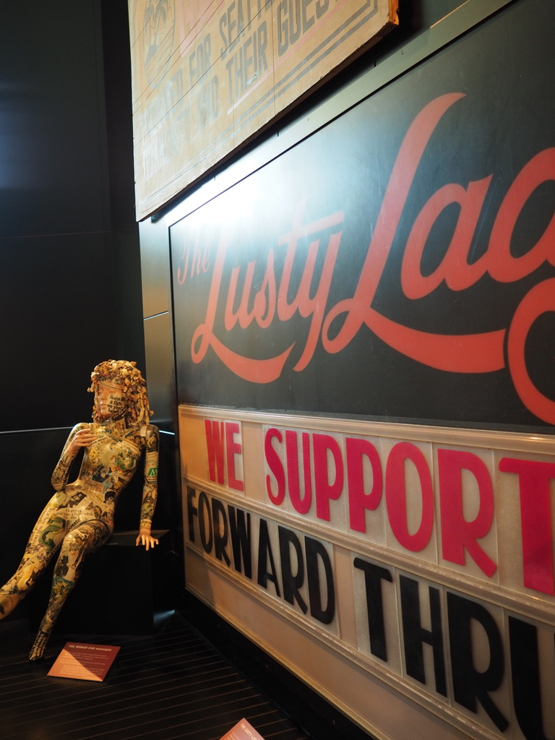After several, civilization movement gives more people inspiration and enthusiasm to exercise, elaborate their innovation thoughts, it is important to a city’s development I thought. When the electronic dynasty came, this city is already prepared to welcome this new things, Microsoft, Amazon, and many start-up company prove this.

The things I am confusing about is the low-speed infrastructure building speed can support this trend in the future or not, because my friend told me that the population in Seattle grew up very fast, and I saw I5 highway’s traffic jam every morning.